**Databases Laboratory Work Nr. 1**

**Title: ,,Creating and maintaining the database,,**

**Prerequisites:** SQL Server 2017 and all it’s necessary components.

**Objectives:**

* Learning how to create a database.
* Learning how to maintain a database.

**Tasks:**

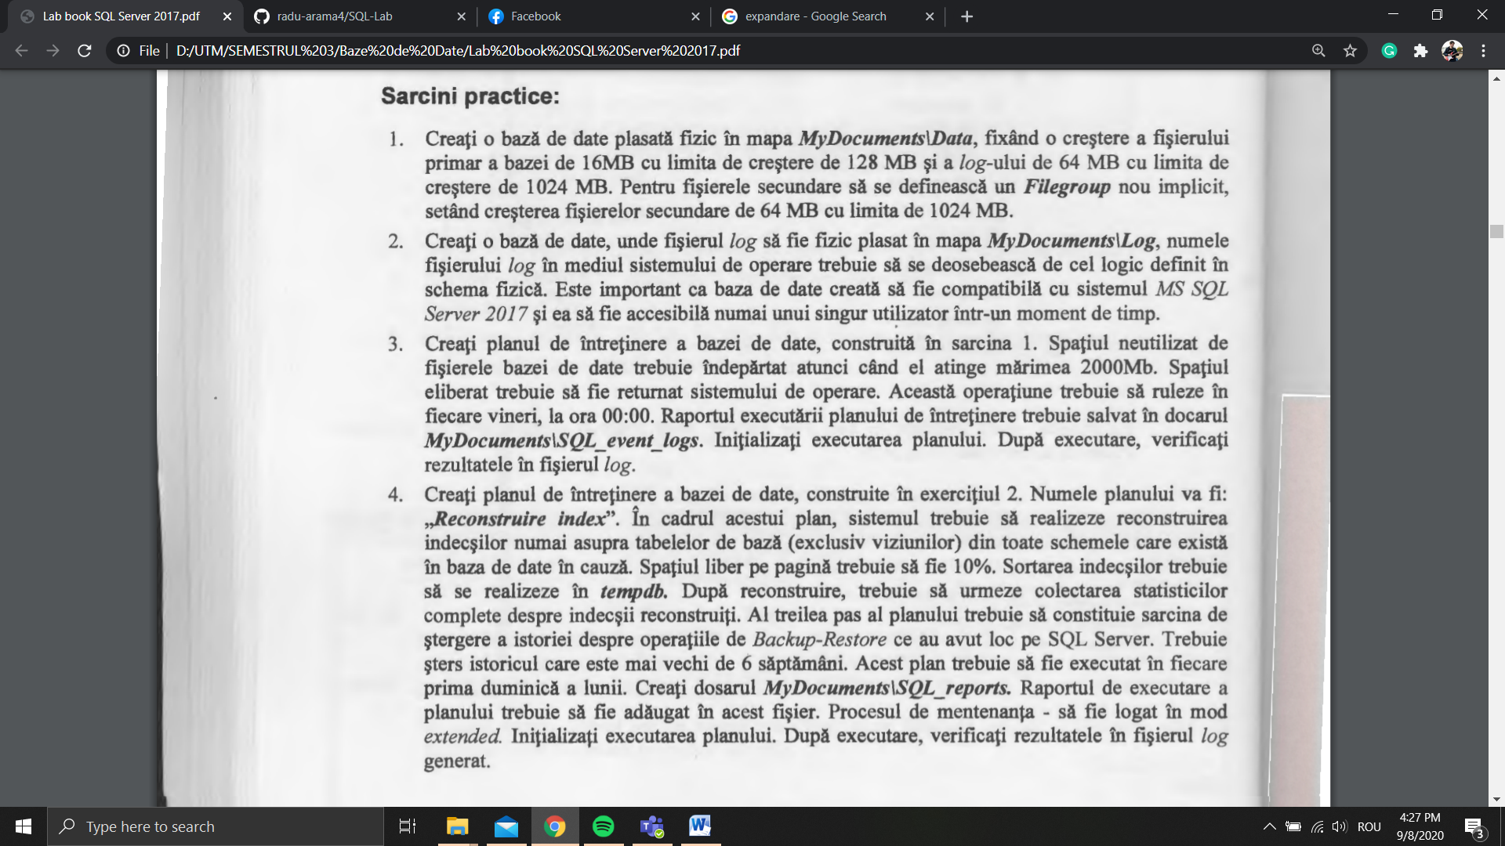

**Implementation:**

**1.**

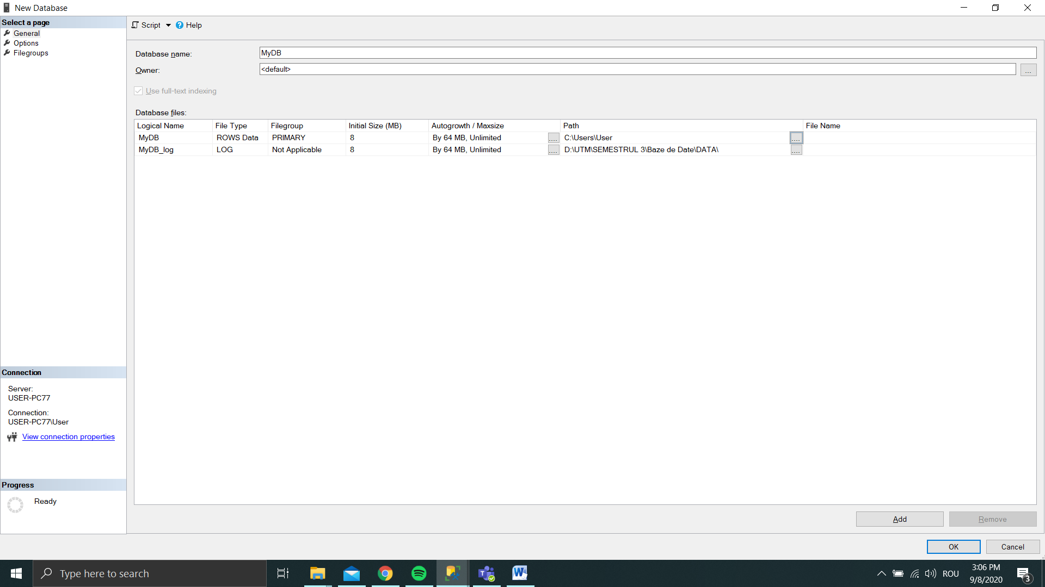

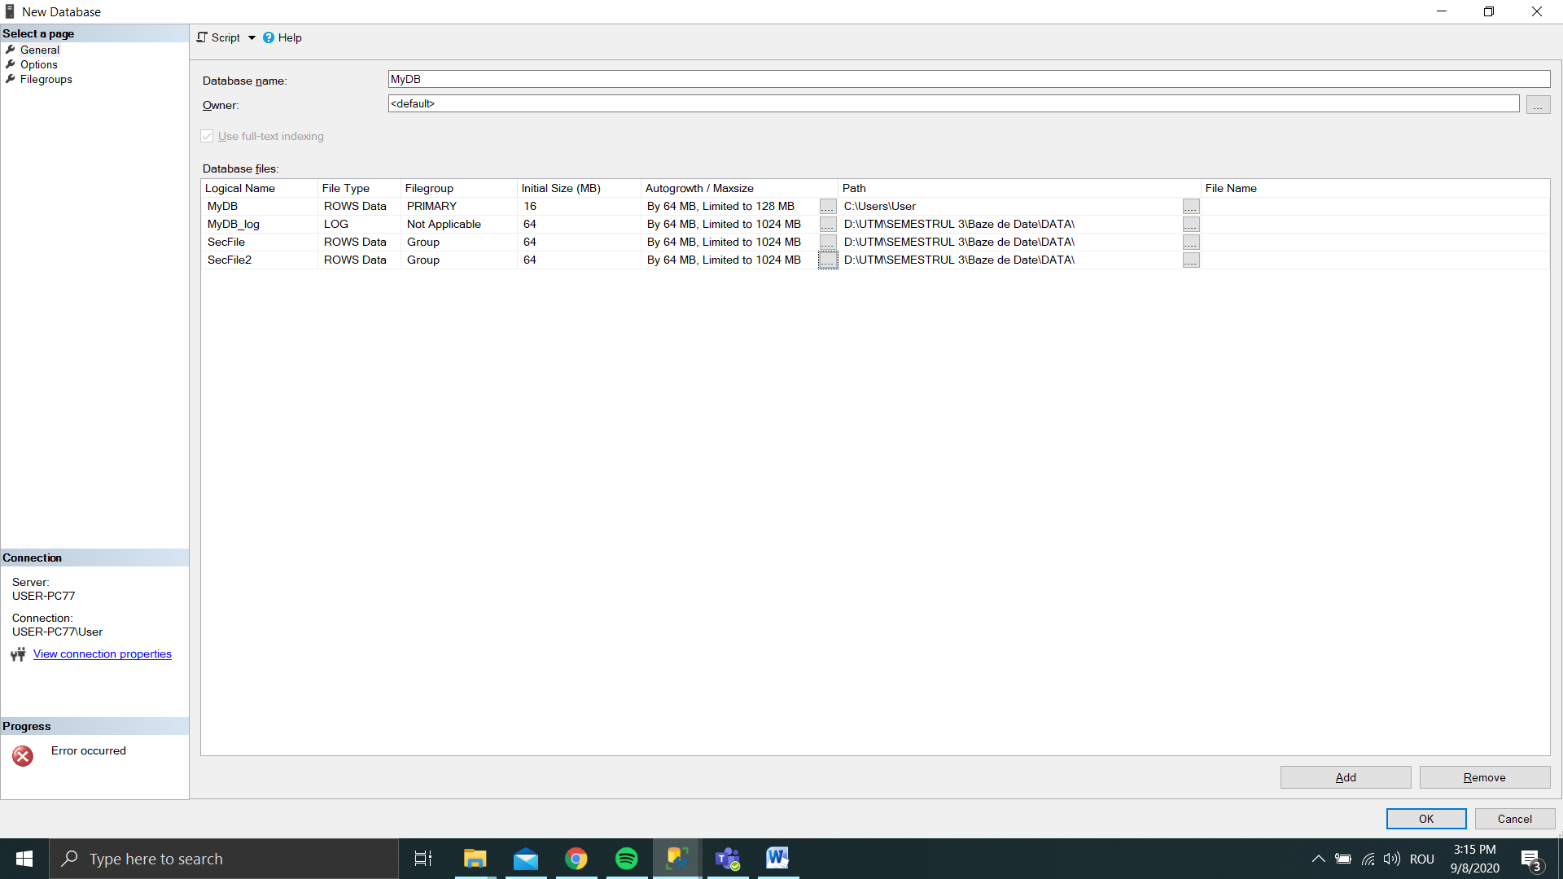

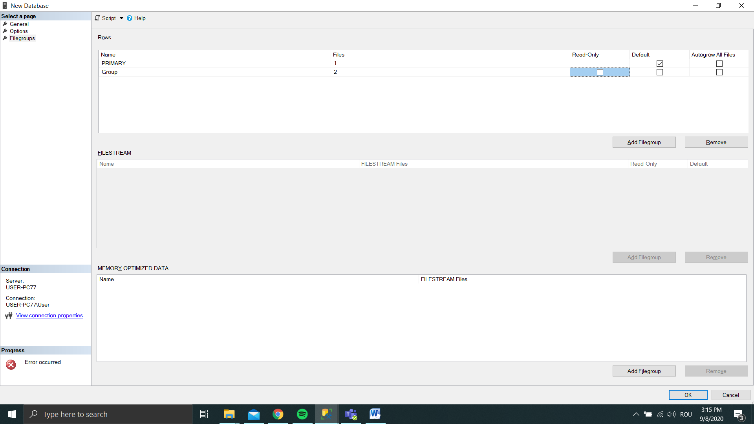

**2.**

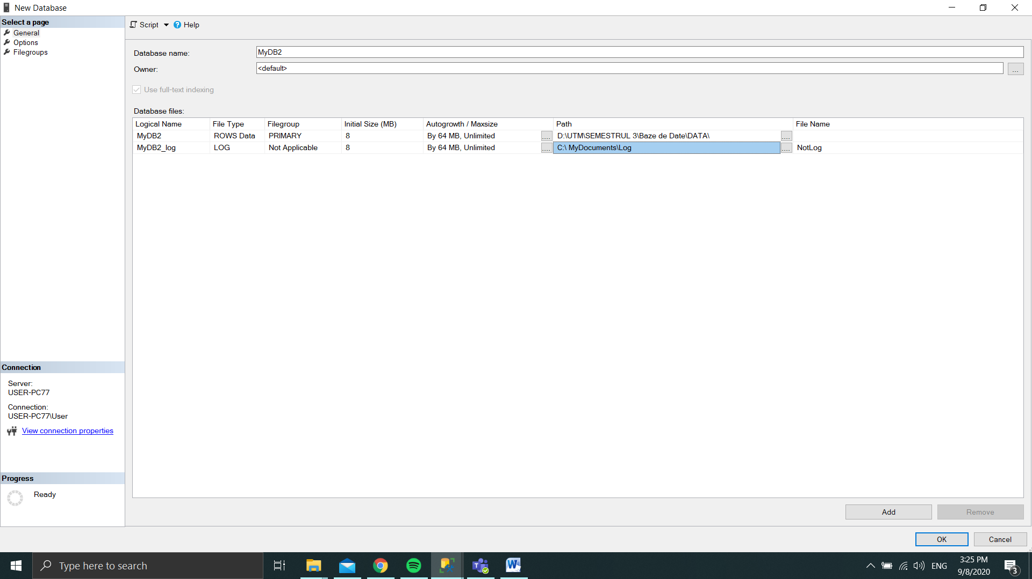

**3.**

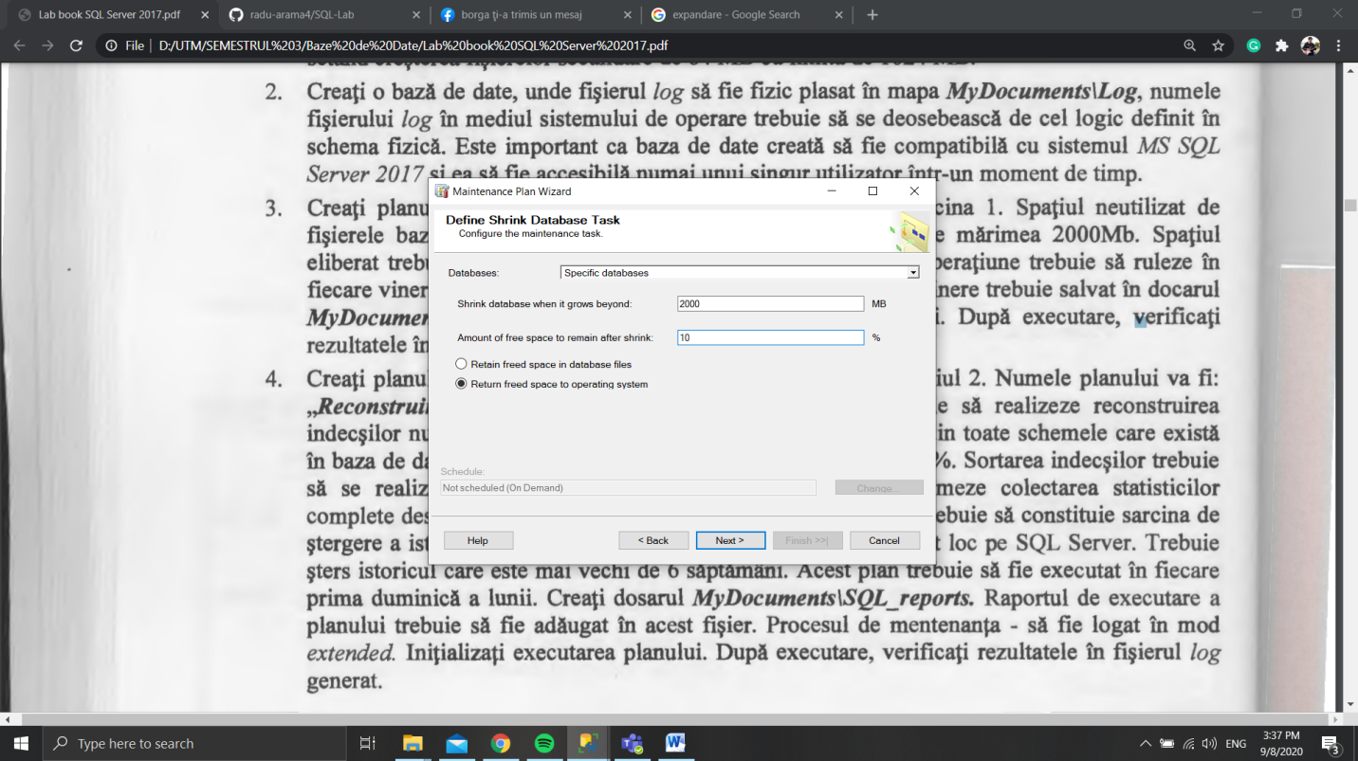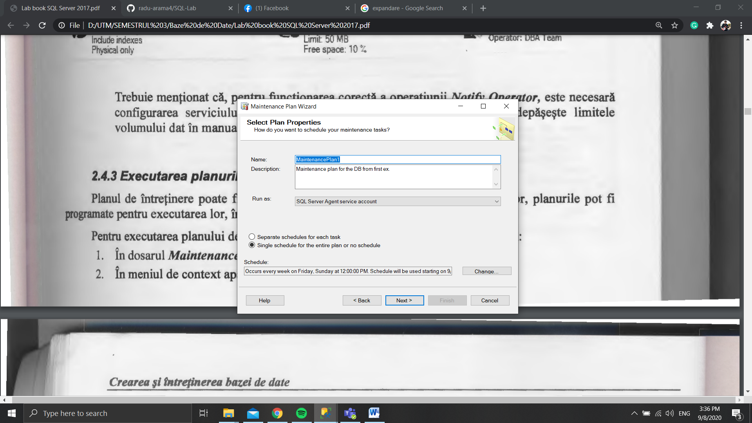

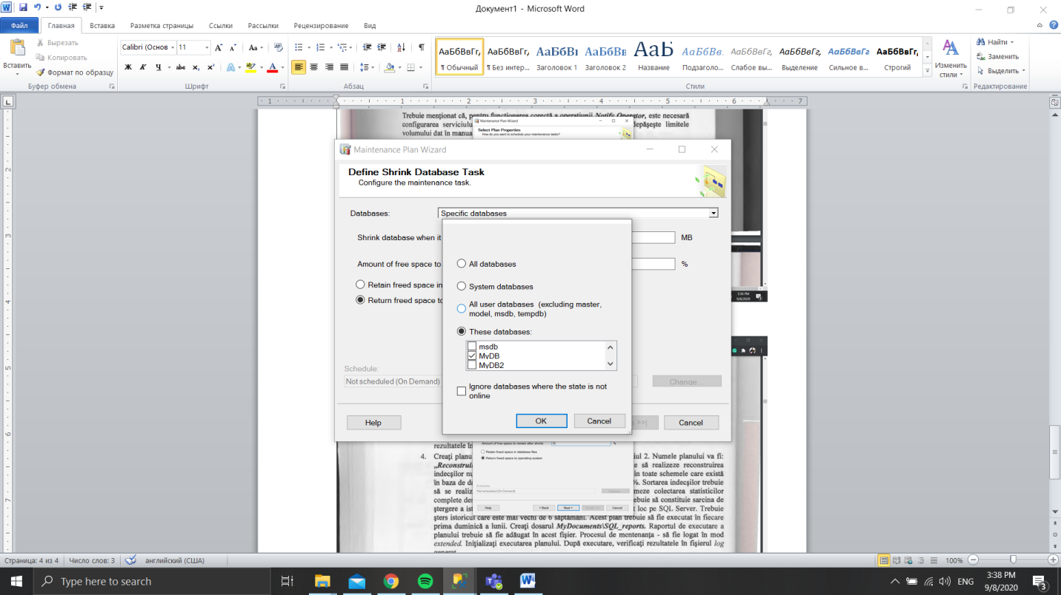

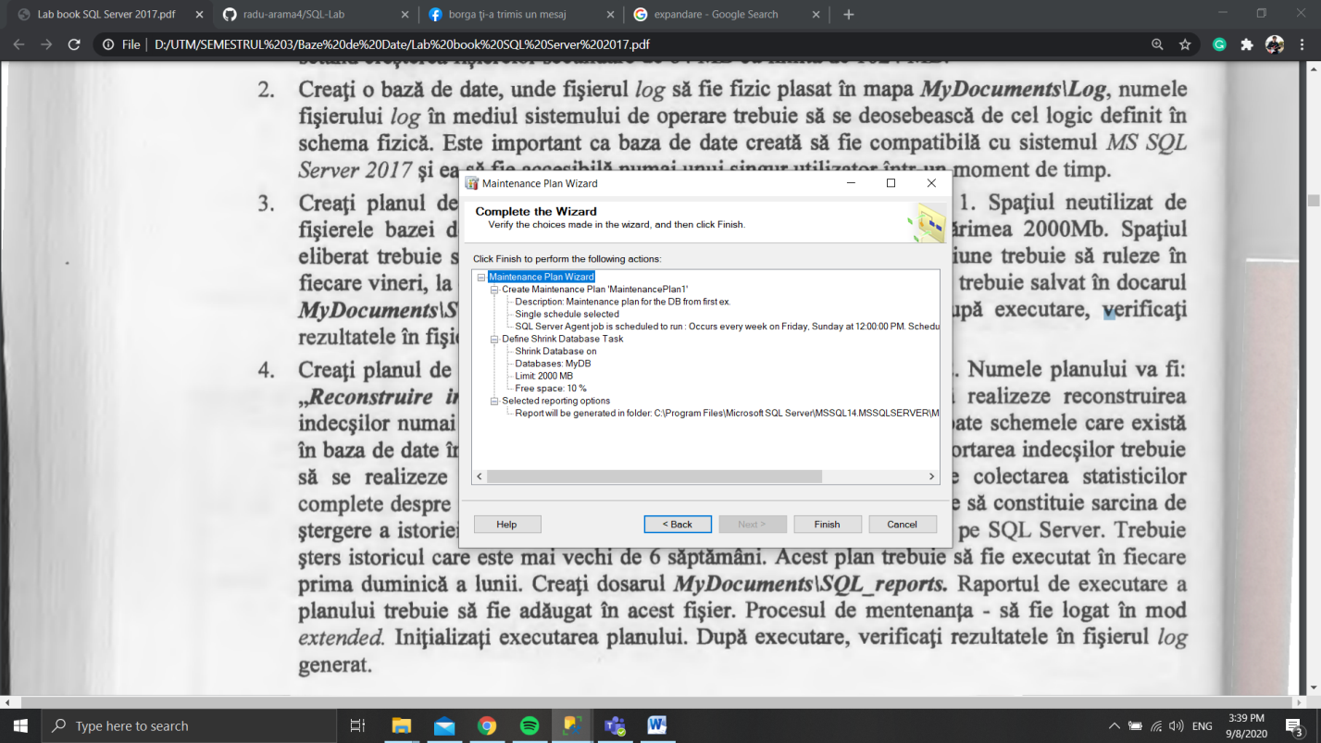

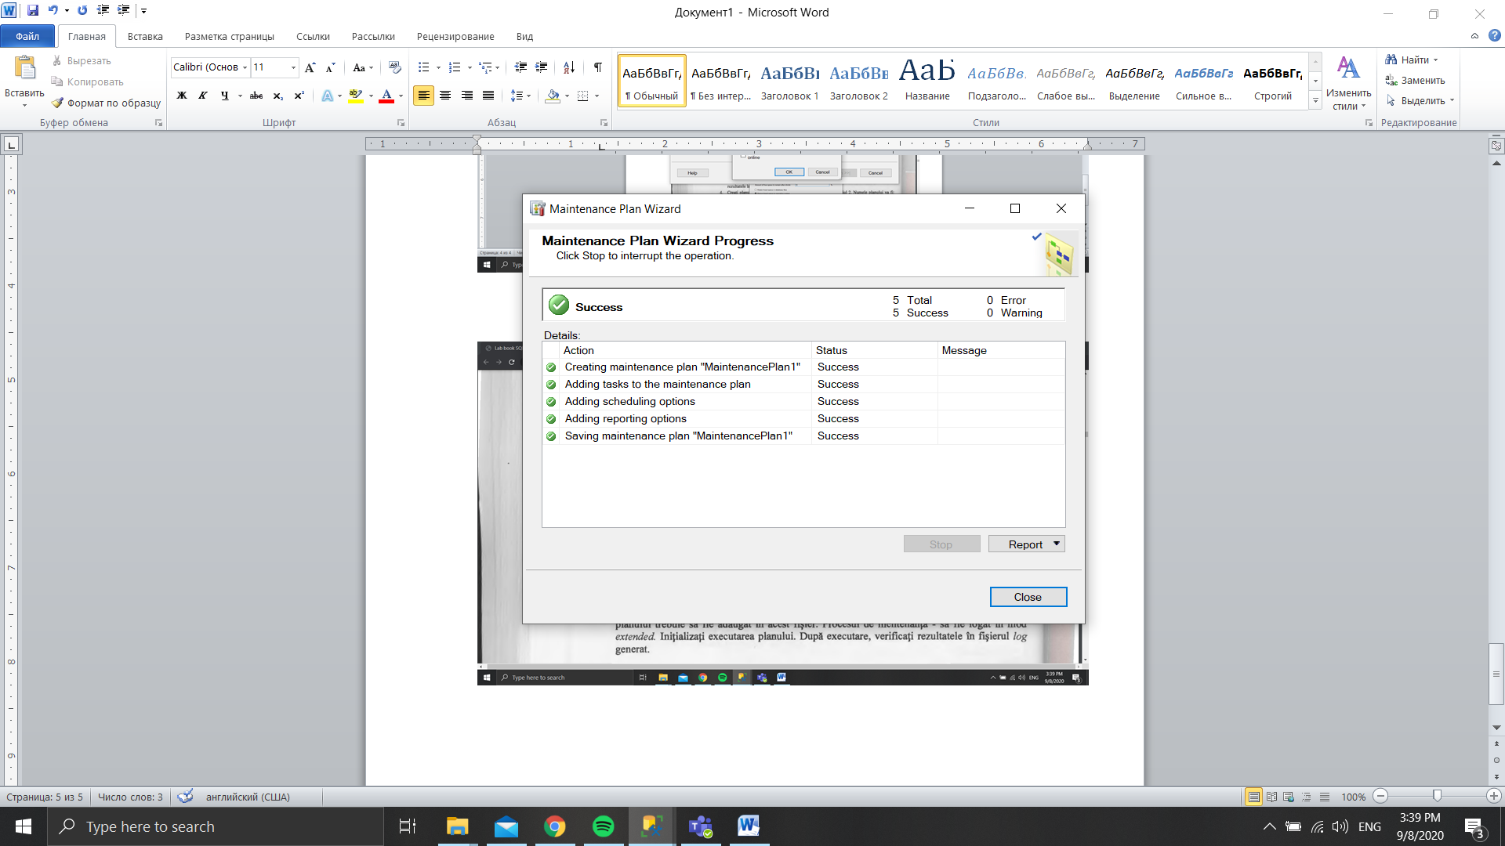

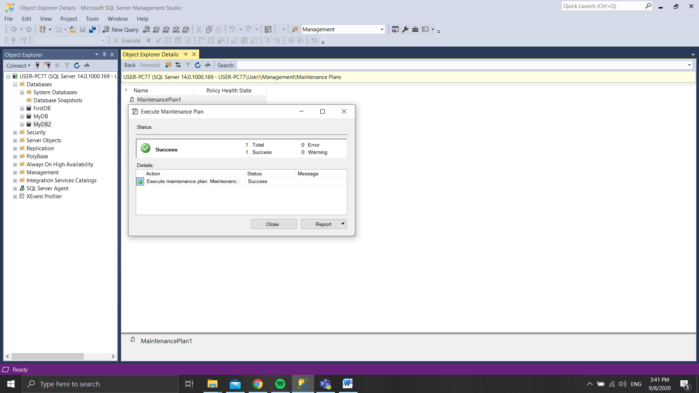

**4.**

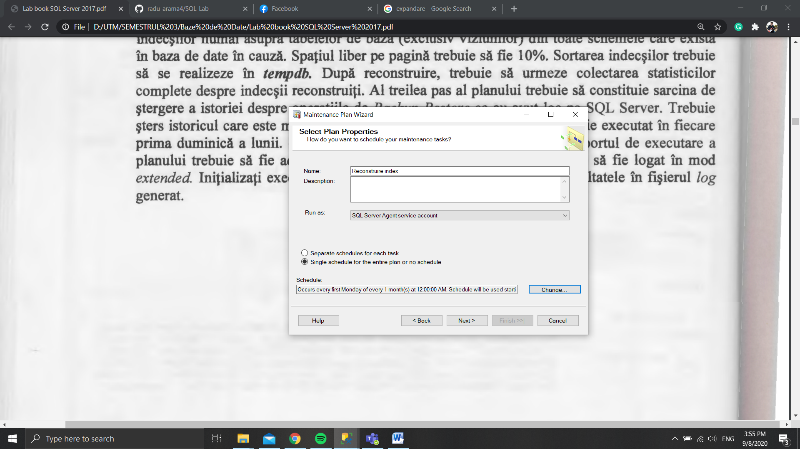

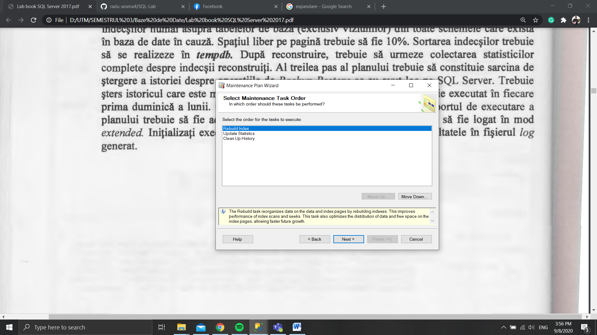

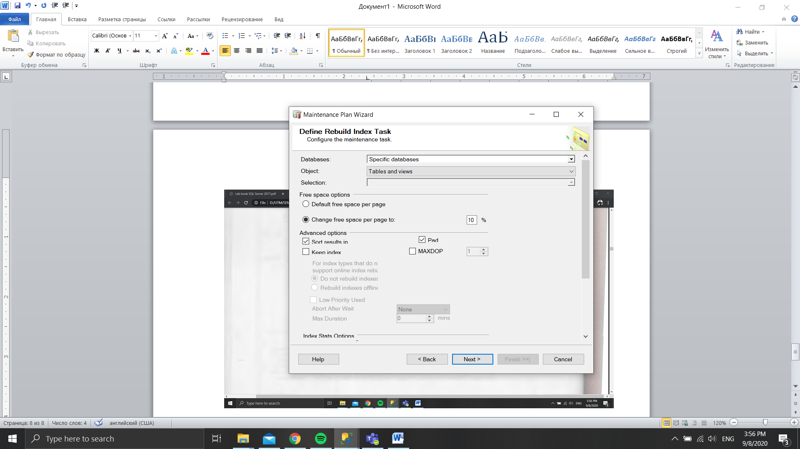

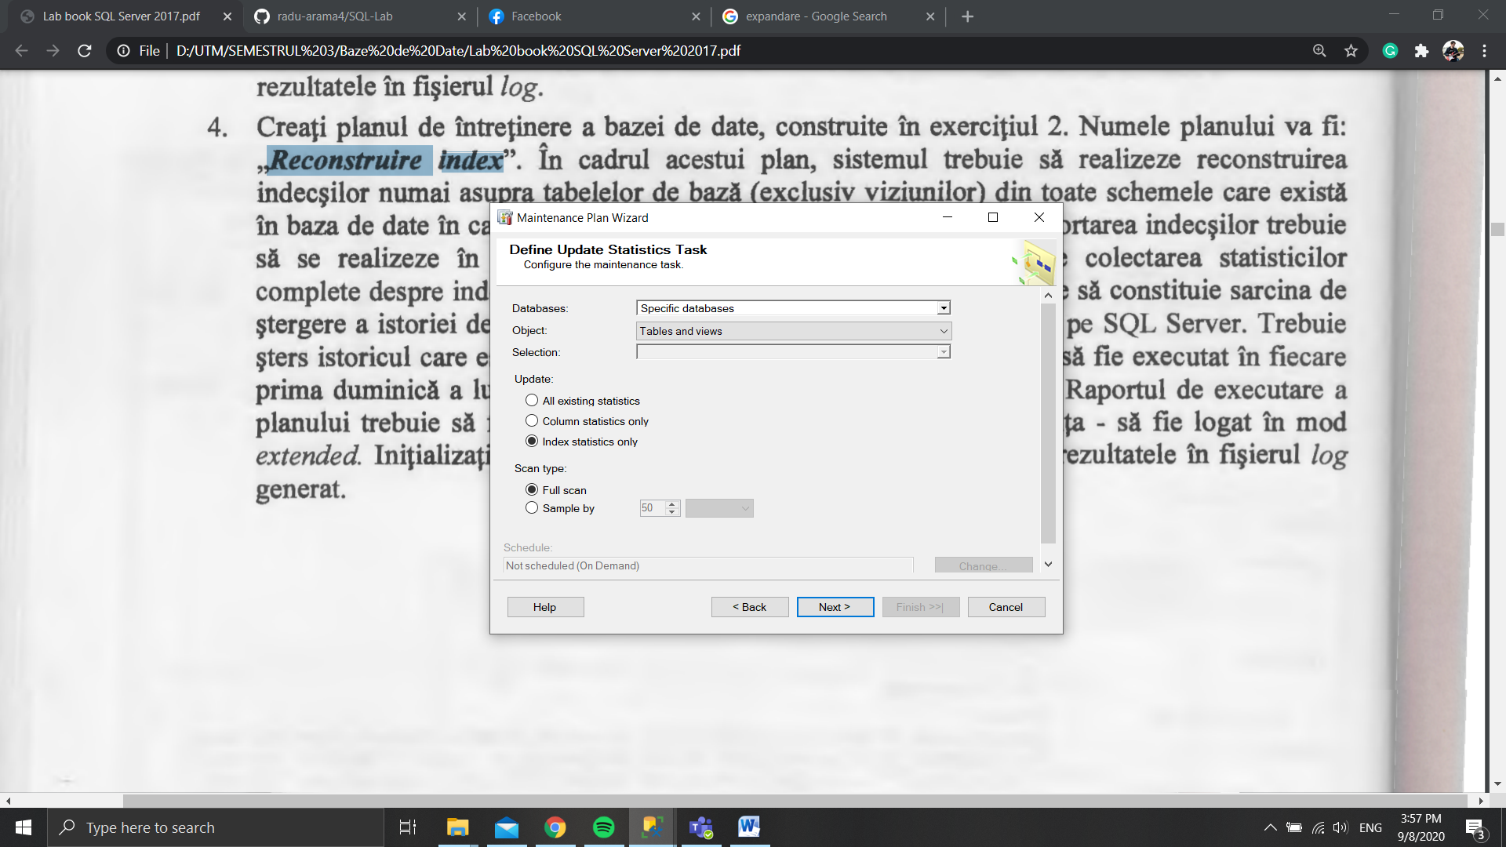

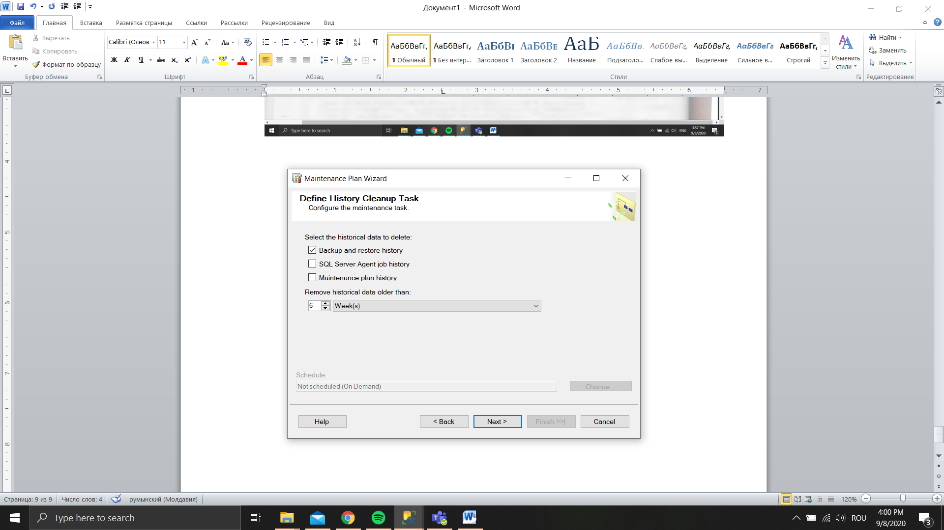

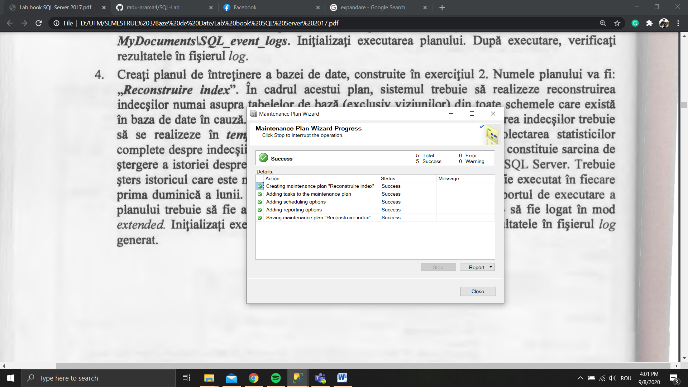

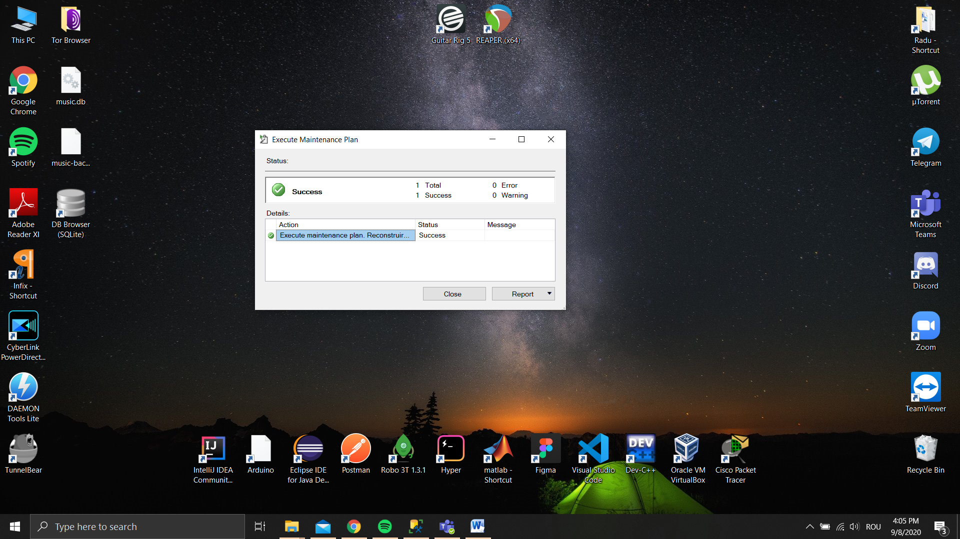

**Conclusion:**

After doing these tasks I improved my ability of creating and maintaining a database using SQL Server 2017. I can say that this SGBD offers powerful tools for this purpose and they are not difficult to use. Also, these tools are very flexible, for example the Maintenance Plan Wizard, which I used to create and automatize a maintenance plan for a specific database.

**Aramă Radu-Vasile**

**FAF-193**